Assignment 3

UOW ID: 7770029

Implementation of blockchain system simulating proof-of-work

To run the program: Open two command program, run Alice_A3.py on one side and Bob_A3.py on the other program

Implementing threading to stop the process in the middle of computation.

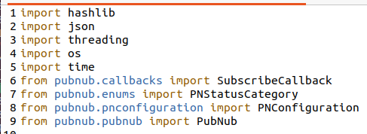

Using the publish key and subscribe key for the pubnub

The codes will generate the folder for Alice and Bob to store the mined block inside.

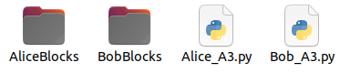

Example of the block mined by Alice midway through

Example of the block mined by Bob midway through

Example of the block mined by Alice, when first mined it would be added to the folder and then it would verify the block. If the block is invalid (not verified), the block would then be removed from the folder.

Example of the block mined for Bob, and some logic as Alice in verification of block.

